Parish of Aston Cantlow

A meeting of the Parish Council for the above named Parish will be held on 11th July 2024 in Aston Cantlow Village Hall at 7.00pm

Dated this 6th day of July 2024
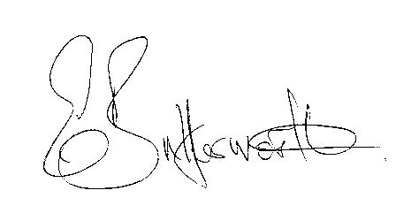Clerk

BUSINESS TO BE TRANSACTED

- Record of Members present.

- To receive apologies and approve reasons for absence.
- Declarations of interest in items on the agenda.
- A representative from the Flood Management Team at WCC to speak about flooding.
- Lady Kilmaine to present details of her land dispute.
- To approve the minutes of the Annual Parish Council meeting and ordinary meeting held on the 9th May 2024.
- Public participation.
- Correspondence: All correspondence circulated electronically is taken as read.
- County & District Councillors’ reports.
10. Planning applications update and to consider Planning application Nos. 24/01616/LBC
and 24/01615/FUL Ardencroft, Newnham: Single storey rear extension and raised terrace with some replacement windows and various repairs to brickwork and timber framing.

11. Dog bin by village hall/social club car park.
12. New model Financial Regulations.
13. Parish Council assets. Update to register.
14. New domain name and new Councillor email addresses - WALC
15. New Fire and Rescue proposals – information provided by County Cllr Kerridge.
16. Update on matters since the previous meeting.
17. Due to the election a revised date for the Police meeting has been arranged.
18. Urgent items not on the agenda raised by Councillors.
19. To propose other items of business for consideration at the next meeting.
20. Date of next meeting: 12th September 2024.

