Parish of Aston Cantlow

A meeting of the Parish Council for the above named Parish will be held on 12th September 2024 in Aston Cantlow Village Hall at 7.00pm

Dated this 6th day of September 2024

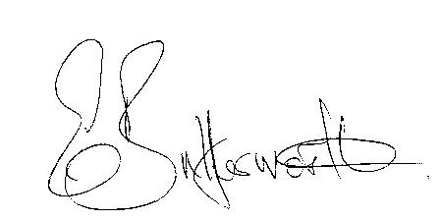Clerk

**BUSINESS TO BE TRANSACTED**

1. Record of Members present.
2. To receive apologies and approve reasons for absence.
3. Declarations of interest in items on the agenda.
4. To approve the minutes of the Parish Council meeting held on the 11th July 2024.
5. Public participation.
6. Correspondence: All correspondence circulated electronically is taken as read.
7. County & District Councillors’ reports.
8. Resignation of Parish Councillor.
9. New dog bin to replace the old one by the village hall, and small dog fouling signs.

10. Planning applications update and to consider Planning application No.24/02125/TREE

T2 on plan - Ash tree: Reduce to the same height as agreed in the 2022 application.

11. Request from the Church Treasurer for a grant towards the repairs to the churchyard

mower.

12. Parish Council Assets: update on progress with register

13. New domain name and new Councillor email addresses - WALC

14. Due to the election the revised date for the Police meeting is now 26th September.

15. Consideration of some form of signage at the junction of Mill Lane/Brook Road for safety

Purposes relating to the driveway into Glebe Farm.

16. Urgent items not on the agenda raised by Councillors.

17. To propose other items of business for consideration at the next meeting.

18. Date of next meeting: 14th November 2024.