Parish of Aston Cantlow

A meeting of the Parish Council for the above named Parish will be held on 14th November 2024 in Aston Cantlow Village Hall at 7.00pm

Dated this 8th day of November 2024

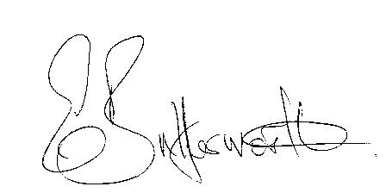Clerk

**BUSINESS TO BE TRANSACTED**

1. Record of Members present.
2. To receive apologies and approve reasons for absence.
3. Declarations of interest in items on the agenda.
4. To approve the minutes of the Parish Council meeting held on the 12th September 2024.
5. To consider requests from Ms. S. Ekins and Mrs M. Hudson to be co-opted onto the Council. There is currently one vacant seat.
6. Public participation.
7. Correspondence: All correspondence circulated electronically is taken as read.
8. County & District Councillors’ reports.
9. Planning applications update and to consider the following:

Planning application No.24/02680/TREE Olde Forge, Bearley Road, Aston Cantlow: Fell Lawson Cypress.

Planning application No.02268/LBC Holyoake House, Little Alne - repair scheme to timber frame following structural failure.

1. New domain name and new Councillor email addresses.
2. Update/modernise Website to link with above item.
3. Update on items since the previous meeting.
4. Urgent items not on the agenda raised by Councillors.
5. To propose other items of business for consideration at the next meeting.
6. Date of next meeting: 16th January 2025.