Parish of Aston Cantlow

A meeting of the Parish Council for the above named Parish will be held on 16th January 2025 in Aston Cantlow Village Hall at 7.00pm

Dated this 11th day of January 2025

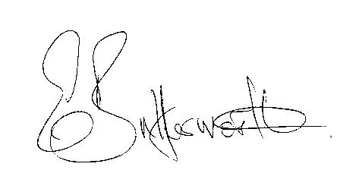Clerk

**BUSINESS TO BE TRANSACTED**

1. Record of Members present.
2. To receive apologies and approve reasons for absence.
3. Declarations of interest in items on the agenda.
4. To approve the minutes of the Parish Council meeting held on the 14th November 2024.
5. Public participation.
6. Correspondence: All correspondence circulated electronically is taken as read.
7. County & District Councillors’ reports.
8. Planning applications update.
9. Precept request for 2025/26.
10. New noticeboard to replace the one by the village hall damaged in the storms.
11. New domain name and new Councillor email addresses.
12. New upgraded website circulated for review.
13. Update on items since the previous meeting.
14. Urgent items not on the agenda raised by Councillors.
15. To propose other items of business for consideration at the next meeting.
16. Date of next meeting: 13th March 2025. Annual Parish Assembly followed by an ordinary Parish Council meeting.