Parish of Aston Cantlow

A meeting of the Parish Council for the above named Parish will be held on 28th July 2021 at 8.00 in the Guild Hall, Aston Cantlow

Dated this 23rd day of July 2021
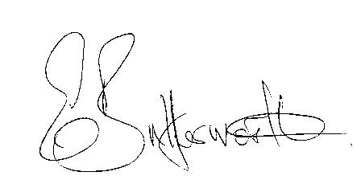Clerk

BUSINESS TO BE TRANSACTED

- Record of Members present.
- To receive apologies and approve reasons for absence.
- To receive written requests for Disclosable Pecuniary Interests or Non-Pecuniary interests where that interest is not already in the register of members’ interests.
- To approve the minutes of the ordinary Parish Council meeting held on 29th April 2021
and Annual Parish Council meeting held on 6th May 2021.
- Public participation: To receive any questions or presentations from the public.
- County & District Councillors reports.
- Planning Matters update.
To consider Planning application Nos 21/02145/FUL and 21/02146/LBC 20 Bearley Road, Aston Cantlow: Proposed replacement of four timber casement windows and repairs to two first floor dormers.
- Correspondence received: All correspondence sent electronically to date will be taken as read.
- Village Hall Committee request for previously agreed S137 grant towards playground upkeep.
- Lengthsman – update resulting from invitations to interested parties.
- Traffic through Little Alne – Cllr. FitzGibbon request for more signage.
14. Date of next meeting: 11th November 2021.

